

My Target: ____ / 40 or ______ % Complete on the day of the test

🖒 🖓 (Circle when your test is handed back)

**Name: _______ Teacher:**

Yr 8 Humanities & Social Sciences:

*The Ancient to Modern World*

|  |  |  |
| --- | --- | --- |
| Total marks  **/40** | **%** | **Weight** |
|  |  |  |

***Task Two:***

***Causes and Effects of the Black Death Graphic Organiser***

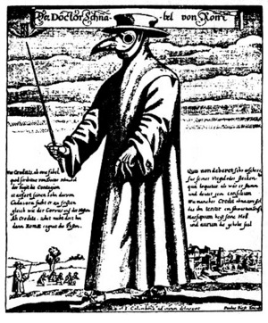

**Task Part A.**

You are to investigate the cause of the spread of the Black Death throughout Medieval Europe and the effects of this spread Death. As part of this investigation you will have to complete the following tasks:

* Write focus questions
* Make notes using a note making structure of your own choice
* Compile a bibliography using the framework provided
* Select and use an appropriate Graphic organiser to display causes and effects of the Black Death. (The graphic organiser will be completed on a separate sheet)

**You will be given 4 periods to complete this task.**

**Task Part B. Validation in-class with notes.**

In class time you are to use your graphic organiser to answer validation questions related to causes and effects of the transmission of the Black Death in Europe.

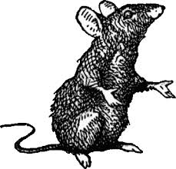

**You will complete this task during 1 period in class time.**

**Instructions to students**

**Causes and Effects of the Black Death**

**Part Ai**

You have four lessons to investigate the cause and effect of the Black Death and then formulate a Graphic Organiser. The graphic organiser must show the causes of the Black Death and also the effects of the Black Death. You will have to choose the most appropriate graphic organiser from the list below;

* Brainstorm
* Flow Chart
* Venn Diagram
* KWL
* Fish bone diagram
* Cause and effect diagram

**Part B**

You have 45 minutes in class to answer a set of questions related to the causes and effects of the Black Death.

**Inquiry process booklet**

1. What do I already know about the topic?

|  |
| --- |
|  |
|  |
|  |
|  |
|  |
|  |
|  |
|  |
|  |
|  |
|  |
|  |
|  |
|  |
|  |
|  |
|  |
|  |
|  |
|  |
|  |

1. What do I need to know?

Brainstorm Concept Map.

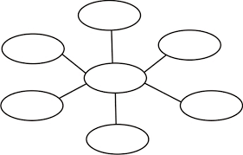

**Focus Question 1**

|  |
| --- |
|  |

**Key points from information sources and reference details**

|  |
| --- |
|  |

**Focus Question 2**

|  |
| --- |
|  |

**Key points from information sources and reference details**

|  |
| --- |
|  |

**Focus Question 3**

|  |
| --- |
|  |

**Key points from information sources and reference details**

|  |
| --- |
|  |

**Focus Question 4**

|  |
| --- |
|  |

**Key points from information sources and reference details**

|  |
| --- |
|  |

**Please print other sheets if you have more focus question**

**Types of Graphic Organisers**

Use the examples and explanations of each graphic organisers use to help you choose the most appropriate graphic organiser.

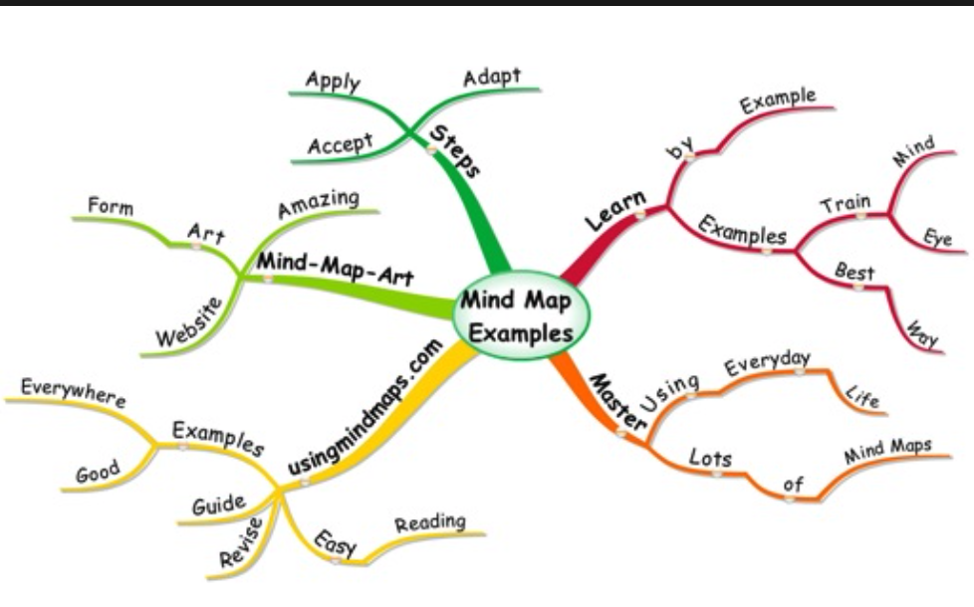

**Brainstorm**

A brainstorm is a graphic organiser that shows a central idea with its corresponding characteristics

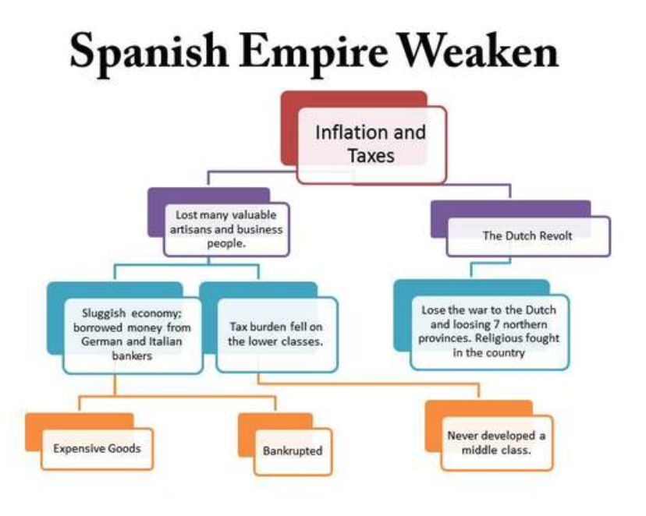**Flow Chart**

A flow diagram or sequence chart shows a series of steps or events in the order in which they take place. Any concept that has a distinct order can be displayed in this type of organizer. A flow chart is excellent for showing the steps necessary to reach a final point.

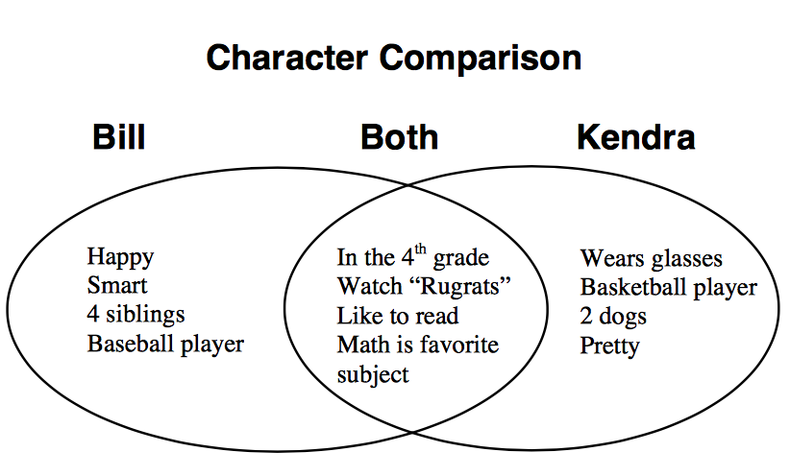

**Venn Diagram**

A compare/contrast or Venn diagram is used to identify the similarities and differences between two or more concepts.

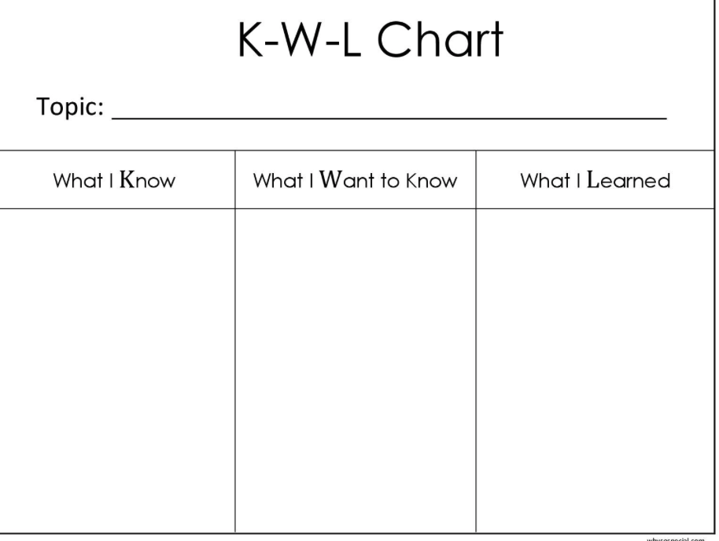**KWL**

A KWL is used to show prior knowledge of a topic and then reflect learning. The letters are an acronym for what you know, what you would like to know and what you learnt.

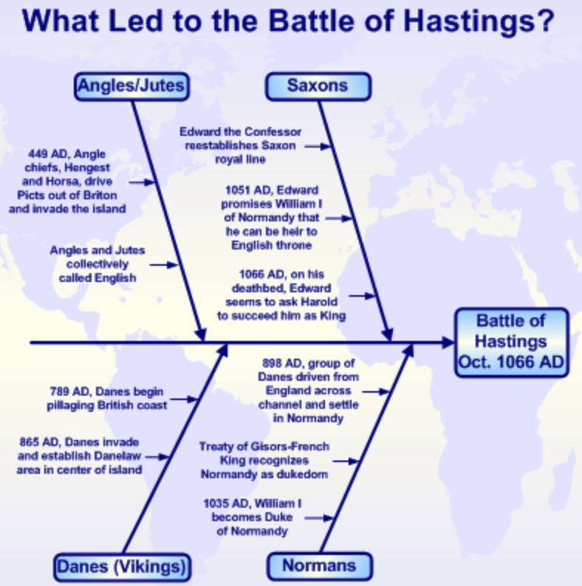

**Fishbone**

The fishbone diagram can help you explore the many aspects of a complex topic. A fishbone diagram is a visualization tool for categorizing the potential causes of a problem in order to identify its root causes.

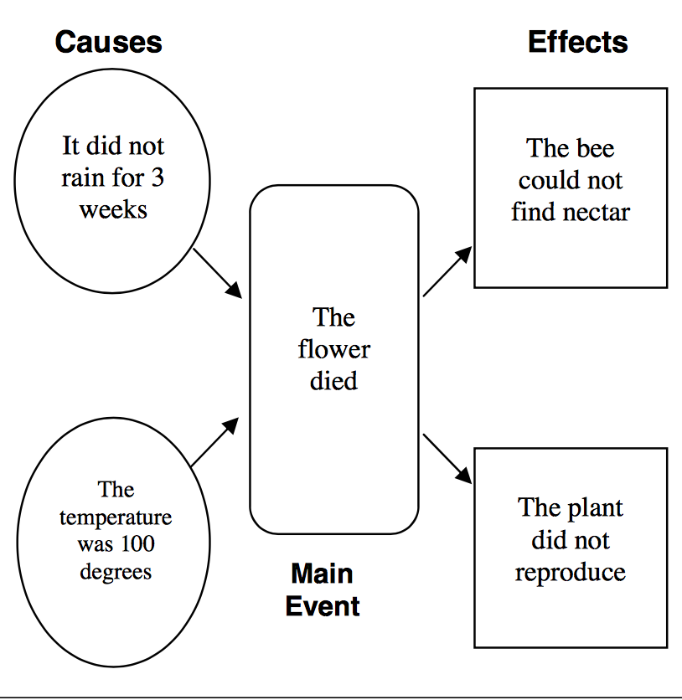**Cause and Effect diagram**

A cause-and-effect diagram highlights the direct relationship between different events or concepts.

**List of resources used**

**The ethical recording and communicating of evidence:** List the bibliography information of all resources from which you have taken information. You are legally required to acknowledge the author or editor who wrote or compiled the information you have used for your assignment.

**Bibliography/reference list framework**

**Books**

|  |  |  |  |  |
| --- | --- | --- | --- | --- |
| **Author** | **Year** | **Title** | **Publisher** | **Place** |
|  |  |  |  |  |
|  |  |  |  |  |
|  |  |  |  |  |
|  |  |  |  |  |
| **More than one author** |  |  |  |  |
|  |  |  |  |  |

**Encyclopaedia or dictionary**

|  |  |  |  |  |  |  |  |
| --- | --- | --- | --- | --- | --- | --- | --- |
| **Author** | **Year** | **Title of article** | **Title of encyclopaedia** | **Volume** | **Publisher** | **Place** | **Page(s)** |
|  |  |  |  |  |  |  |  |
|  |  |  |  |  |  |  |  |

**Magazine articles**

|  |  |  |  |  |  |  |
| --- | --- | --- | --- | --- | --- | --- |
| **Author** | **Year** | **Title of article** | **Title of magazine** | **Volume** | **Number** | **Page(s)** |
|  |  |  |  |  |  |  |
|  |  |  |  |  |  |  |
|  |  |  |  |  |  |  |

**Newspaper article**

|  |  |  |  |  |  |
| --- | --- | --- | --- | --- | --- |
| **Author** | **Year** | **Title of article** | **Title of newspaper** | **Date** | **Page(s)** |
|  |  |  |  |  |  |
|  |  |  |  |  |  |
|  |  |  |  |  |  |

**Film or video**

|  |  |  |  |  |
| --- | --- | --- | --- | --- |
| **Title** | **Year** | **Format** | **Publisher** | **Place** |
|  |  |  |  |  |
|  |  |  |  |  |

**World wide web – document**

|  |  |  |  |  |
| --- | --- | --- | --- | --- |
| **Author** | **Year or last update** | **Title of website** | **Date retrieved** | **ULR (website address)** |
|  |  |  |  |  |
|  |  |  |  |  |
|  |  |  |  |  |
|  |  |  |  |  |
|  |  |  |  |  |

**World wide web – image**

|  |  |  |  |  |
| --- | --- | --- | --- | --- |
| **Title** | **Format** | **Year** | **Date retrieved** | **ULR (website address)** |
|  |  |  |  |  |
|  |  |  |  |  |
|  |  |  |  |  |

**Online encyclopaedia**

|  |  |  |  |  |
| --- | --- | --- | --- | --- |
| **Title of article** | **Year** | **Title of website** | **Date retrieved** | **ULR (website)** |
|  |  |  |  |  |
|  |  |  |  |  |
|  |  |  |  |  |

**Marking Key**

**Name…………………………..………………………………. /40**

|  |  |  |  |  |  |  |  |  |  |  |  |  |  |  |  |
| --- | --- | --- | --- | --- | --- | --- | --- | --- | --- | --- | --- | --- | --- | --- | --- |
| **Description** |  | | | **Comment** | **1** | | **2** | | **3** | | **4** | | **5** | | **6** |
| 1. **Focus questions.**   Devises a set of questions which clearly identifies the key information needed to address the research question **6 marks** |  | | |  |  | |  | |  | |  | |  | |  |
| Devises a set of questions which identifies some information needed to address the research question  **4 marks** |  | | |  |  | |  | |  | |  | |  | |  |
| Lists a few simple questions which identify limited information  **2 marks** |  | | |  |  | |  | |  | |  | |  | |  |
|  | | | | | | | | | | | | | | | |
| 1. **Selection of information and /or data.**   Selects a range of relevant source that provide clear and accurate information and/or data about the topic.  Selects sources that show a variety of perspectives  **6 marks** |  | | |  |  | |  | |  | |  | |  | |  |
| Selects a few sources that provide some information and/or data about the topic  Selects sources that show some differences in perspectives  **4 marks** |  | | |  |  | |  | |  | |  | |  | |  |
| Uses one or two sources that provide limited information about the topic  **3 marks** |  | | |  |  | |  | |  | |  | |  | |  |
|  | | | | | | | | | | | | | | | |
| 1. **Organisation of information and /or data.**   Organises information and/or data into clear categories using appropriate subheadings  **6 marks** |  | | |  |  | |  | |  | |  | |  | |  |
| Organises information and/or data into some categories using subheadings **3 marks** |  | | |  |  | |  | |  | |  | |  | |  |
| Organises information and/or data in a limited fashion  **2 marks** |  | | |  |  | |  | |  | |  | |  | |  |
|  | | | | | | | | | | | | | | | |
| 1. **Bibliography.**   Follows referencing technique approved by the school  **4 marks** |  | | |  |  | |  | |  | |  | |  | |  |
| Lists sources used **2 marks** |  | | |  |  | |  | |  | |  | |  | |  |
| **Mark** |  | | |  | **1** | | **2** | | **3** | | **4** | | **5** | | **6** |
| 1. **Graphic Organiser: Causes**   Accurately summarises a number of causes responsible for the spread of the Black Death throughout Europe  **6 marks** |  | | |  |  | |  | |  | |  | |  | |  |
| Summarises a few causes responsible for the spread of the Black Death throughout Europe  **4 marks** |  | | |  |  | |  | |  | |  | |  | |  |
| Lists one or two causes for the spread of the Black Death throughout Europe  **2 marks** |  | | |  |  | |  | |  | |  | |  | |  |
|  | | | | | | | | | | | | | | | |
| 1. **Graphic Organiser: Effects**   Accurately summarises a number of short term and long-term effects that the Black Death had Medieval Europe and the world.  **6 marks** |  | | |  |  | |  | |  | |  | |  | |  |
| Summarises a few short term and long-term effects that the Black Death had on Medieval Europe and the world.  **4 marks** |  | | |  |  | |  | |  | |  | |  | |  |
| Lists one or two effects that the Black Death had on Medieval Europe and the World.  **2 marks** |  | | |  |  | |  | |  | |  | |  | |  |
|  | | | | | | | | | | | | | | | |
| 1. **Graphic Organiser Selection**   Chosen Graphic Organiser, is easily interpreted and effectively show’s both the cause and effects of the spread the Black Death throughout Europe.  **6 marks** | |  |  | | |  | |  |  |  | |  | |  | |
| Chosen Graphic Organiser displays the causes and effects of the Black Death somewhat effectively.  **4 marks** | |  |  | | |  | |  |  |  | |  | |  | |
| Chosen Graphic Organiser does not make the link between cause and effect clear.  **2 marks** | |  |  | | |  | |  |  |  | |  | |  | |
| **Total Mark _____/40** | | | | | | | | | | | | | | | |

**COMMENT:**